**Karnataka**

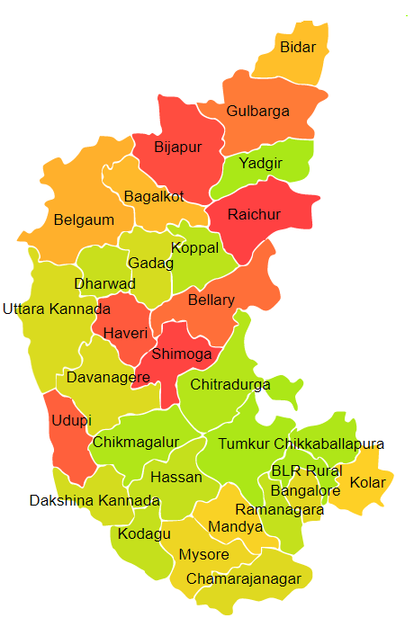

Karnataka comprises of four Agro Ecological Regions (AER) 3,6,8 & 19.

**Agro-Eco Region 3:** AER 3 in Karnataka comprises of Bagalkot, Ballari, Chitradurga and Koppal districts of Deccan Plateau under Agro Ecological Sub Region (AESR)3.

**Agro-Eco Region 6:** AER 6 in Karnataka comprises of Belagavi, Bidar, Davangere, Dharwad, Gadag, Kalaburagi, Raichur, Uttar Kannada, Vijayapura and Yadgir districts of Deccan Plateau under Agro Ecological Sub Regions (AESR) 6.1, 6.2 & 6.4.

**Agro-Eco Region 8:** AER 8 in Karnataka comprises of Bengaluru Rural, Bengaluru Urban, Chamarajanagar, Chikkamagaluru, Chikballapur, Chitradurga, Haveri, Hassan, Kolar, Mandhya, Mysuru and Ramnagar districts of Eastern Ghats under Agro Ecological Sub Regions (AESR) 8.2.

**Agro-Eco Region 19:** AER 19 in Karnataka comprises of Chikkamagaluru, Dakshin Kannada, Kodagu, Shivamogga, Udupi and Uttar Kannada districts of Western Ghats & Coastal Plain under Agro Ecological Sub Regions (AESR) 19.2 & 19.3.